# Exporting the database

Open Neo4j application **as administrator**

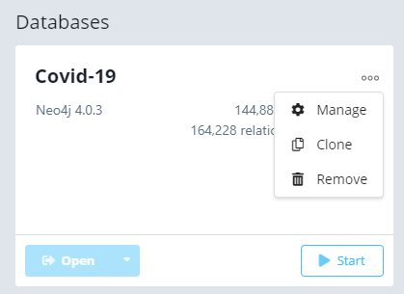

Click **Manage**

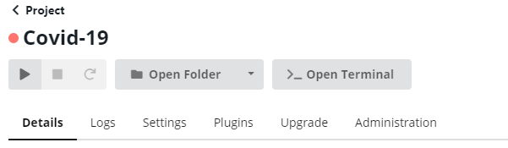

Click **Open Terminal**

In the terminal window that opens paste the following command :

.\bin\neo4j-admin.bat dump --database=neo4j --to=c:\covid-19.dump

The result should be as in the screen below and the file covid-19.dumb that contains the exported database should be located in c:/ :

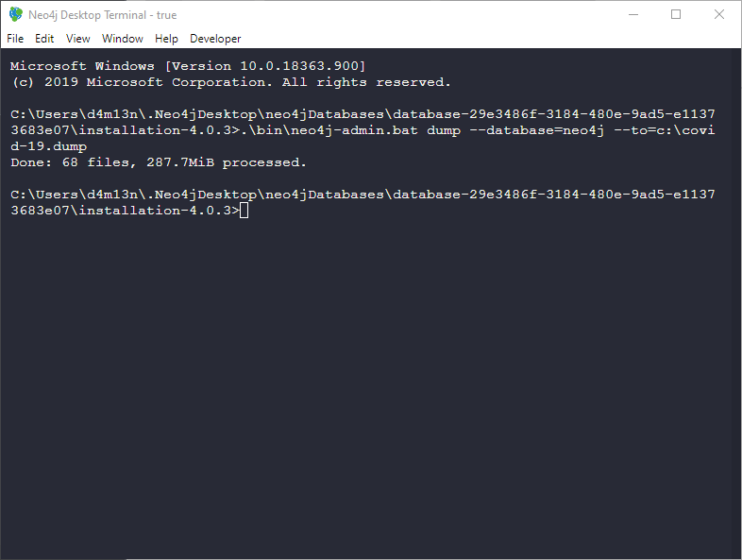

# Ιmporting the database

Place the dump file “covid-19.dump” in c:/ (or wherever the import command refers to)

Open Neo4j application **as administrator**

Create a new database or select an existing one (it should preferably be empty, you can use the

MATCH (n) DETACH DELETE n command to delete everything the make sure the database is STOPPED for the import command to work.

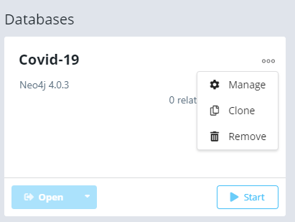

Click **Manage**



Click **Open Terminal**

In the terminal window that opens paste the following command :

.\bin\neo4j-admin.bat load --from=c:\covid-19.dump --database=neo4j --force

The result should be as follows

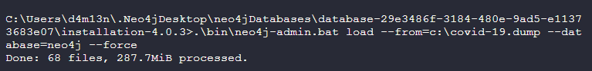

And the database should now be restored when pressing start

